**ASSIGNMENT**

**MODULE-3**

**CLOUDWATCH ALARMS**

**Done By**

**RANJITH KUMAR**

**Tasks To Be Performed:**

1. Create a CloudWatch billing alarm which goes off when the estimated

charges go above $500.

2. Create a CloudWatch alarm which goes off to an Alarm state when the

CPU utilization of an EC2 instance goes above 65%. Also add an SNS

topic so that it notifies the person when the threshold is crossed.

**TASKS:**

**STEP 1 :** Open Cloudwatch from aws services

**STEP 2 :** In alarms select Billing and click create alarm

**STEP 3 :** In select metric select EC2 and choose for which billing alarm is needed

**STEP 4:** Select the time period for the alarm

**STEP 5 :** Choose threshold greater than 500

**STEP 6 :** In configure actions select In alarms , create a new topic , give topic name , Give email for receiving notification and click create topic

**STEP 7 :** Give alarm name and click next

**STEP 8 :** In preview and create previously entered details are shown

**STEP 9 :** Click Create alarm

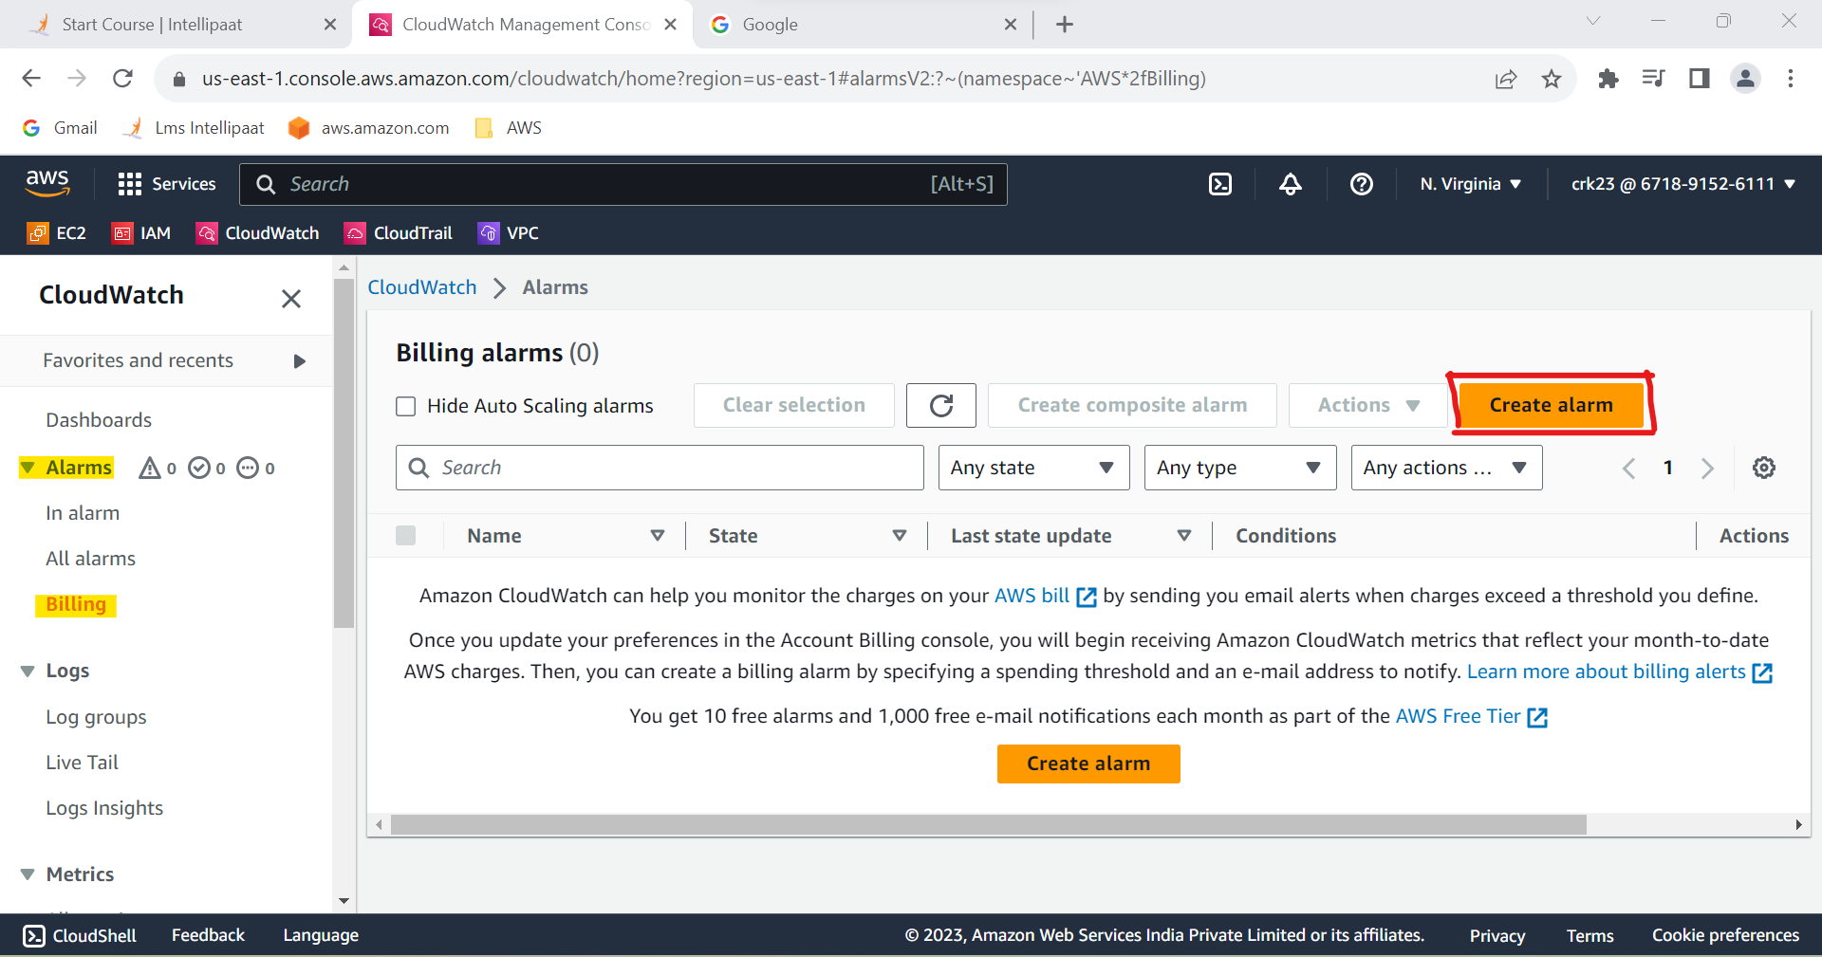

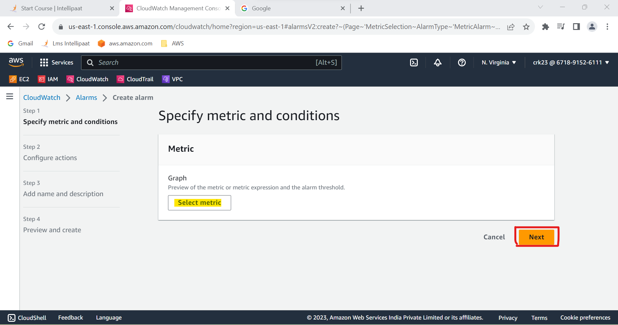

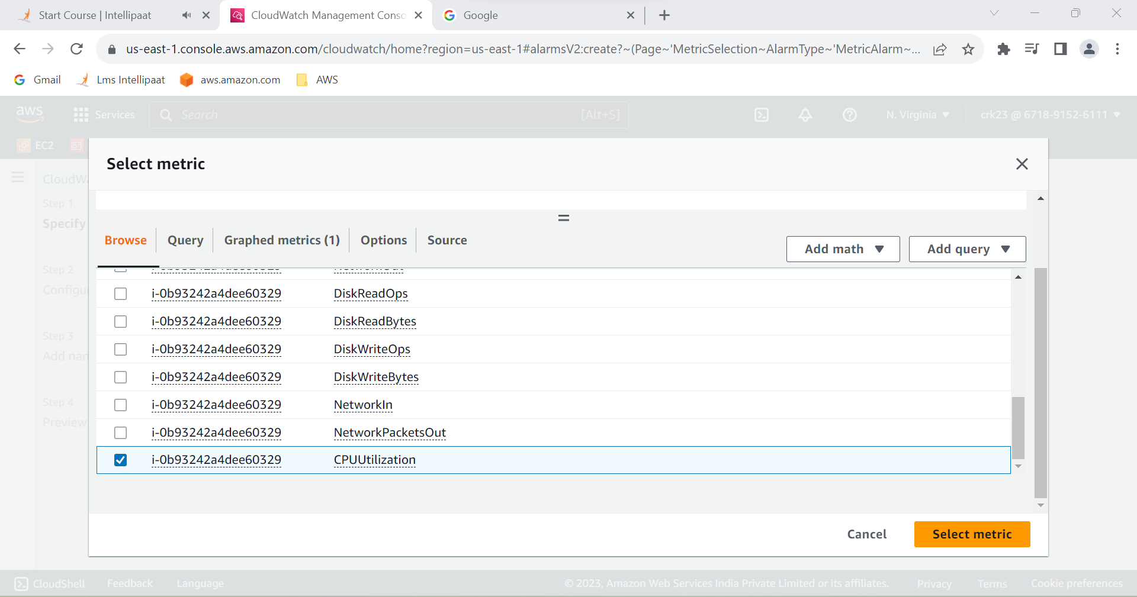

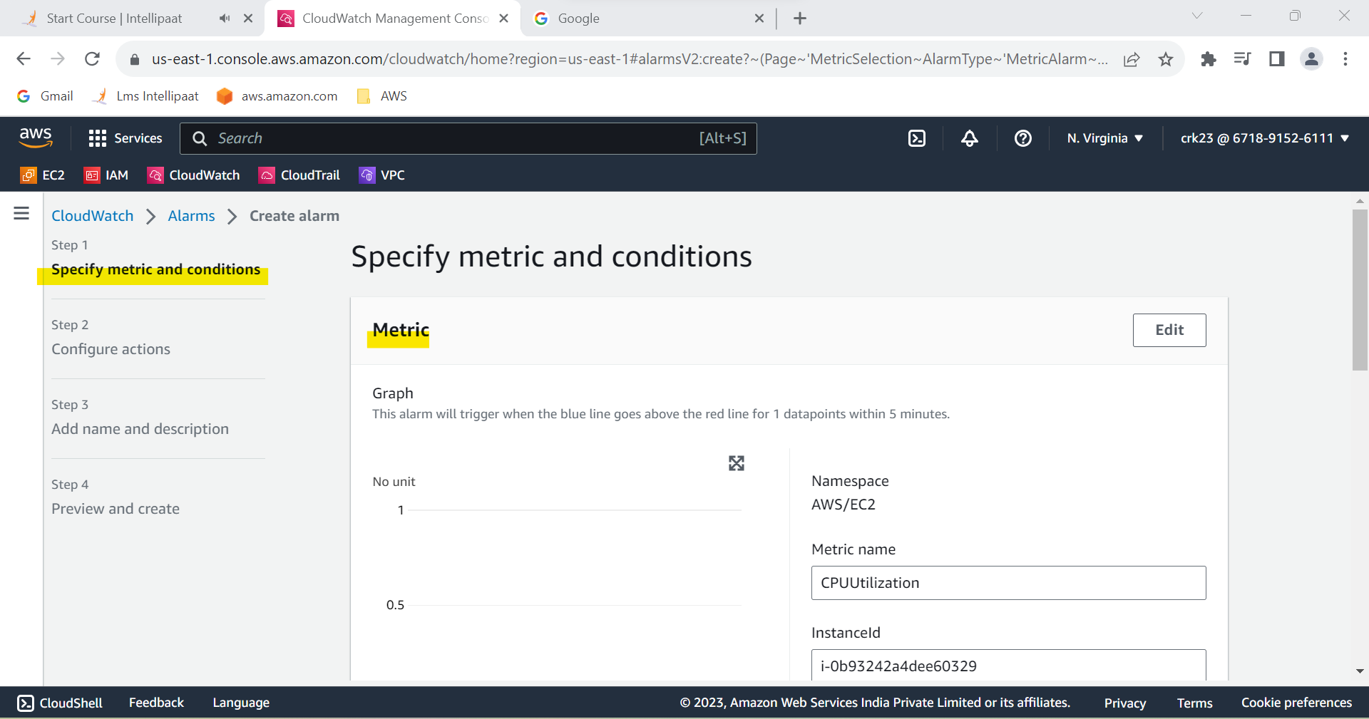

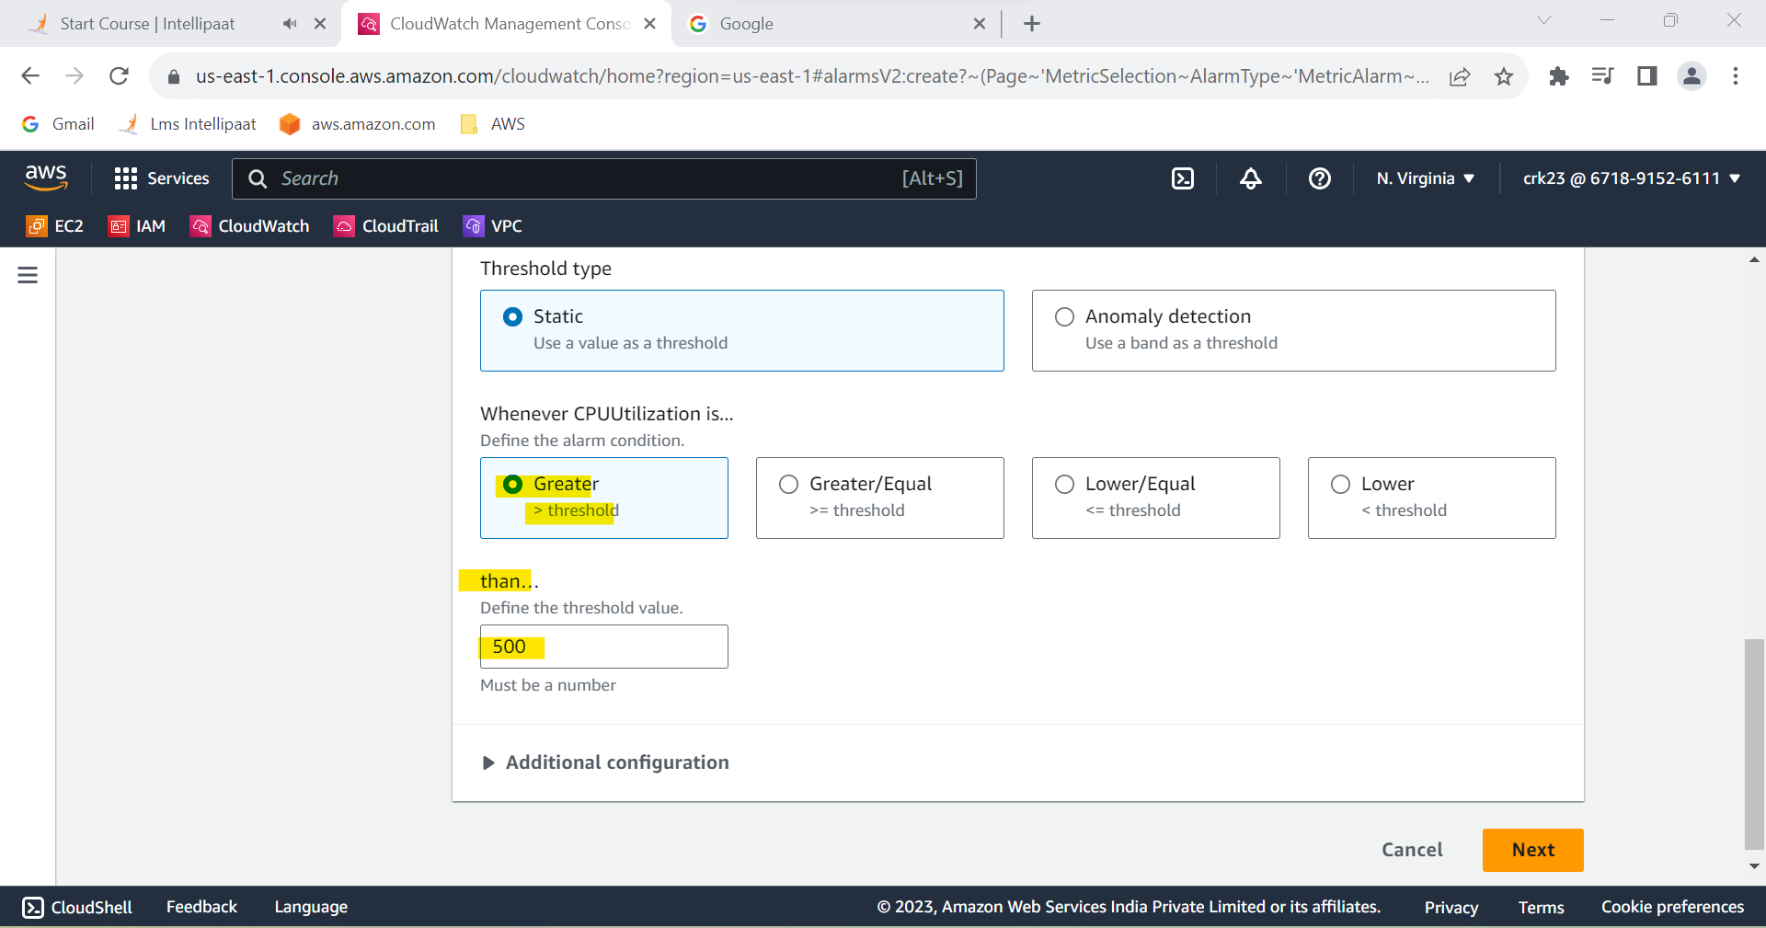

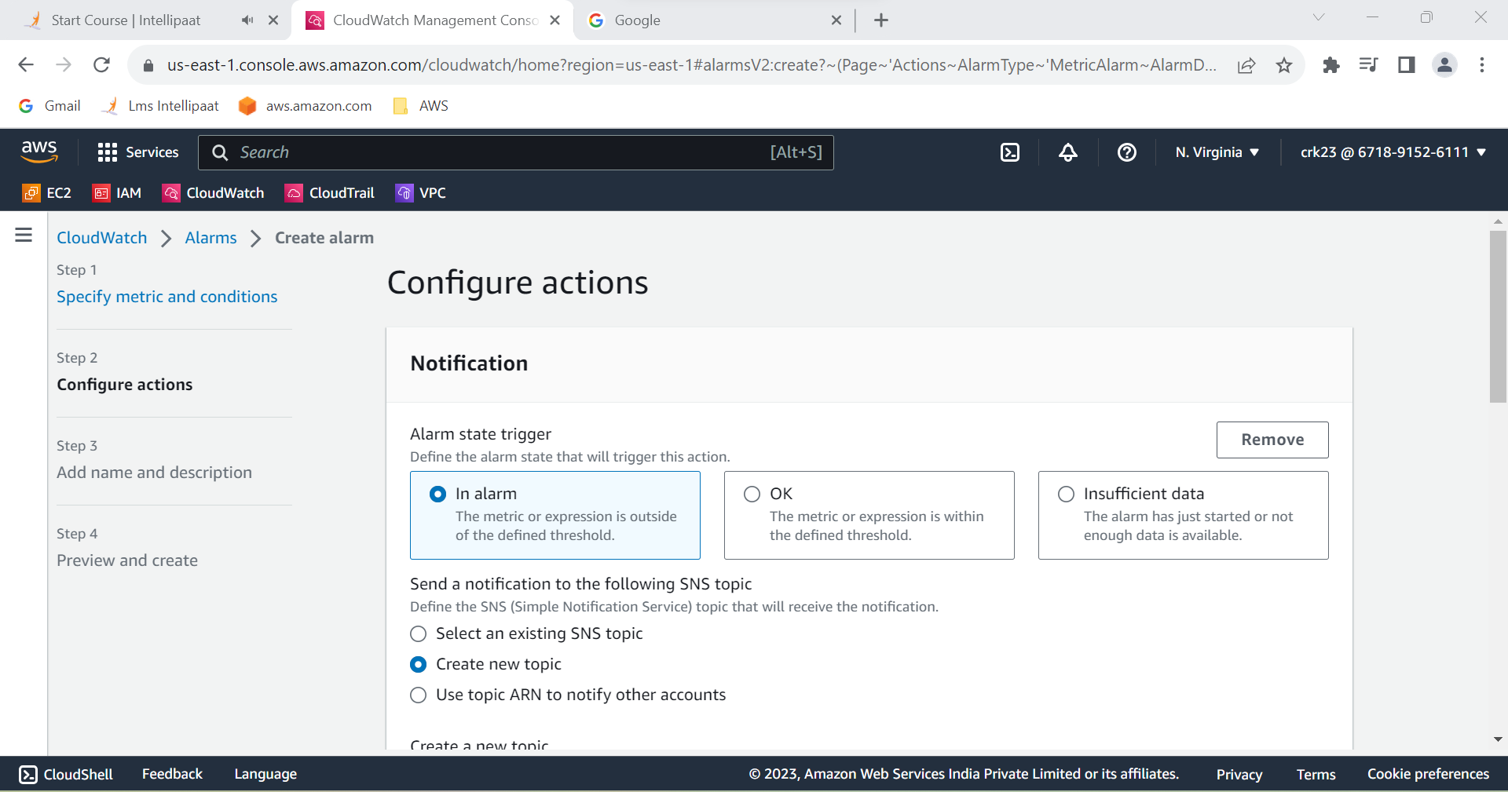

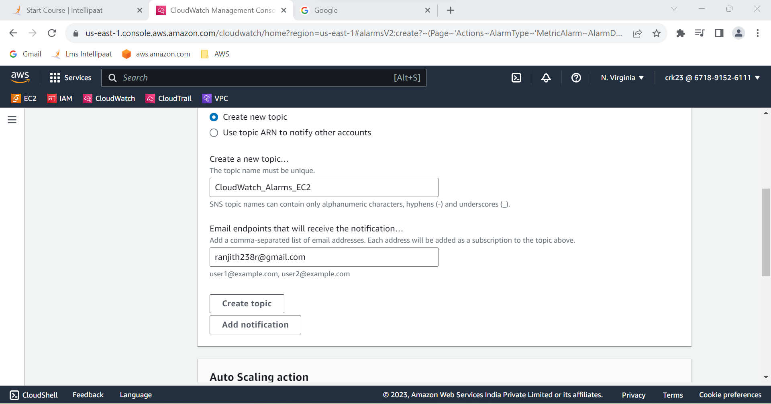

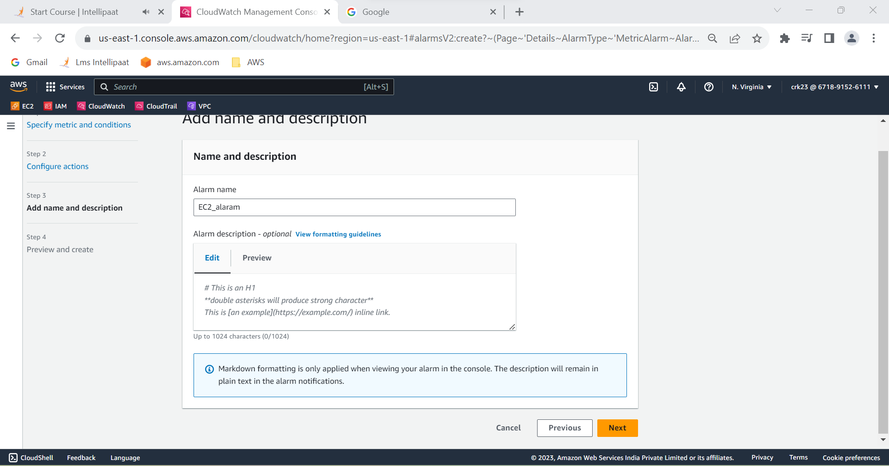

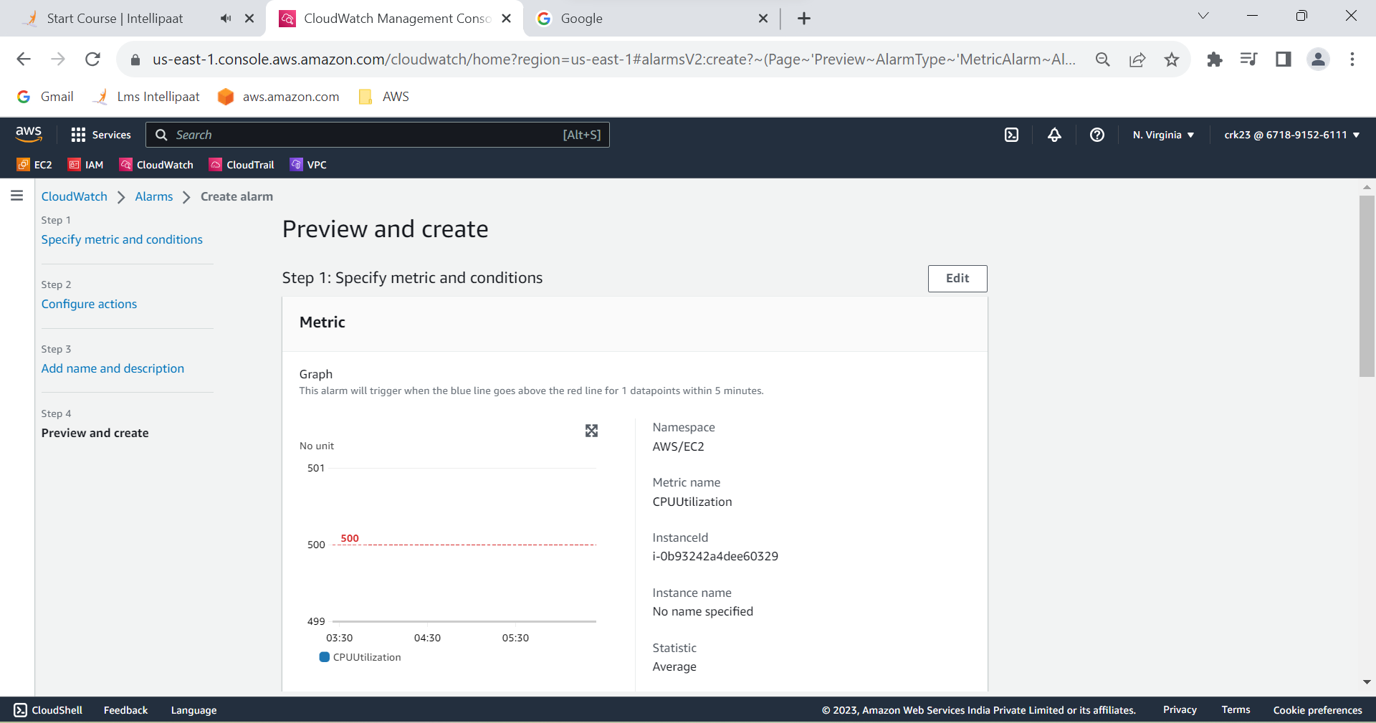

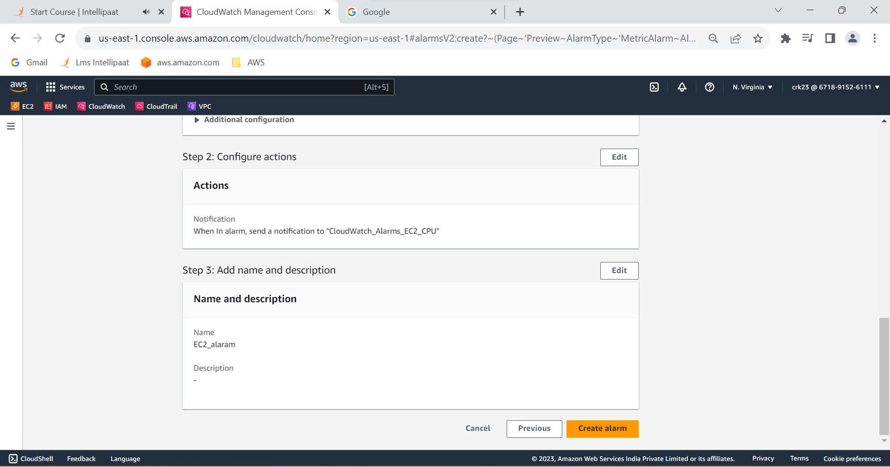

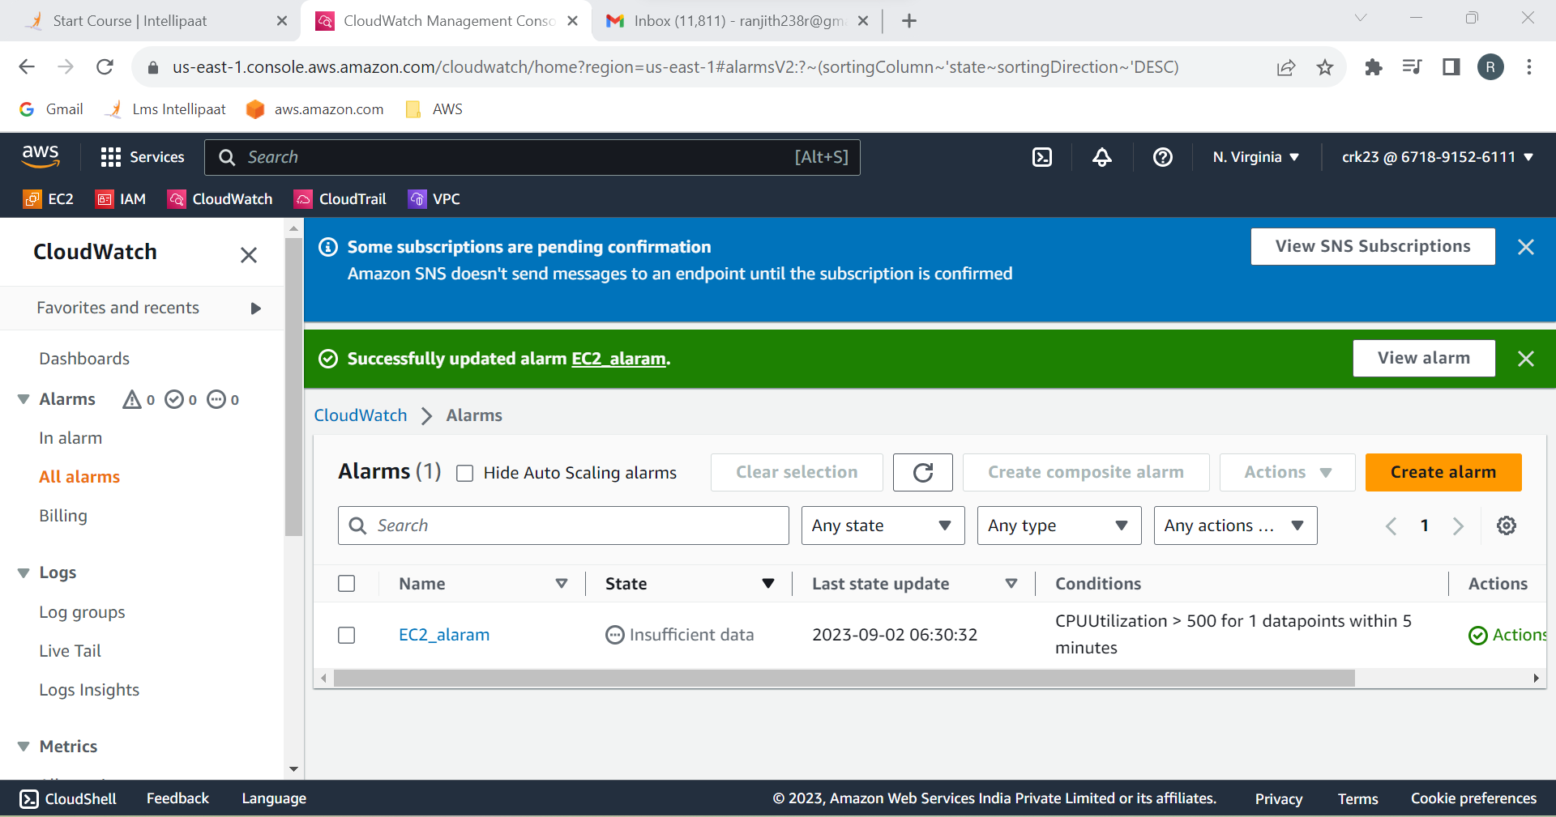

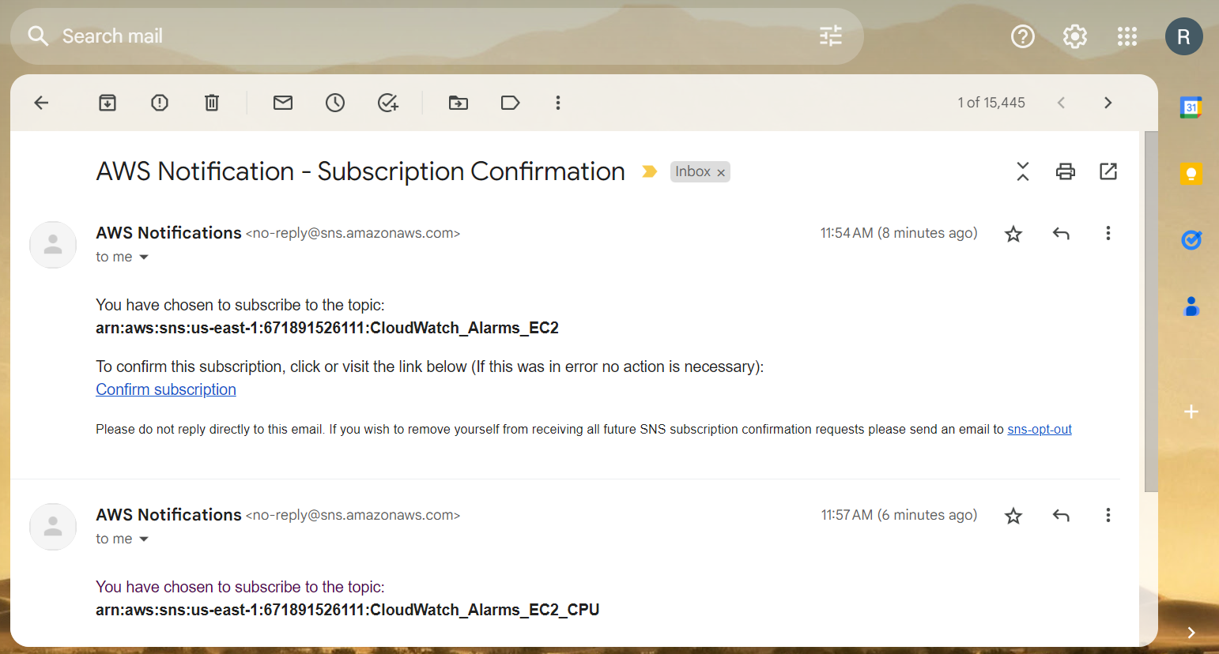

**TASK OUTPUT :**

Created a CloudWatch billing alarm which goes off when the estimated

charges go above $500 and CloudWatch alarm which goes off to an Alarm state when the CPU utilization of an EC2 instance goes above 65%. Also add an SNS topic so that it notifies the person when the threshold is crossed.